Summer 16 Meeting Minutes

Exec Council Minutes (7/10) 2
President – Alaquinez 2
1st VP – Beith 2
1st VP Elect – Valdez 3
2nd VP Elect – McCutcheon 3
Executive Director – Campbell 3
Treasurer – Akers 3
Secretary – Gilbert 4
College Rep – Gale 4
High School Rep – Valentine 4
Lifetime Member Rep – Conley Hall 4
PD Coordinator – Dawn Tucker 4
Webmaster – Sawyer 4
Immediate Past Prez – Peerbolte 5
Committee Reports 5
Scholarship – Akers 5
TOC – Valdez/Alaquinez 5
Publicity and Promotion – Higdem 5
Debate Topic Selection – Gilbert 6
Student Congress – Zack Tucker 6
Fall Conference 16 6
Old Business 7
Demo Day 7
Thespians 7
Tournament Behavior 7
Filling Committees 8
Theatre Committee 9
NFHS IE Conference 10
Archivist 10
Journal Editor 10
StuCo Permanent Director 10
New Business 10
YouTube copying of pieces 10
“No” List 11
Addition of Events 11
Summer Meeting 11
Announcements 11
Attached Reports 12
President’s Report 12
Executive Director’s Report 13
Treasurer’s Report 14
Scholarship Committee 16

Exec Council Minutes (7/10)

President Alaquinez called the body to order at 1:43
- moved and seconded that we accept the meeting. Motion passed
Officer Reports

President – Alaquinez
- following TOC dealt with coach and parent
+ fault was with the student and NOT the Association
- looking to fill Archivist role and Journal Editor
- Professor Mead was interested in the role
- concern with Alaquinez doing too much next year
- Ethics violations that are floating around
+ if we have a violation it needs to be written (hand) and sent to Gale. This way we have a concrete paper trail
- Focusing on theatre based PD
+ Pris and Sarah could possibly with community theatre

- Point of Order (Valdez) Jennifer dropped her diet Coke on green carpet
-

1st VP – Beith
- having the convention
- sent menu choices out last night
- have a tentative schedule done
- PD is not quite full
- rate is $109 per night
- Examine the phenomenon of “Black Lives Matter”
+ Rosie, Stacy, Kim, etc – panel discussion
- Akers INTERJECTS
+ Income $5750 Expenses $7437
+ We need to decide if we need to go up on conference pricing; killed the account for a couple of months
- Sawyers INTERJECTS
+ insert in registration that if you aren’t staying in the block of rooms that you will be charged $15 if you don’t stay in the rooms the Association has
+ Even commuters will be assessed the fee
- Dawn Tucker proposed new policy regarding registration for Fall ConferenceEarly Bird one fee, Past Deadline $30 increase on the Early Bird, and Week Before $60 increase on the Early Bird. Day registrations will increase at a rate of $15. The $15 increase will apply to the college level. $20 increase in fee for the conference ($110), $20 fee (Facilities Access Fee) for not staying in the reserved block of rooms
+ passed unanimously

1st VP Elect – Valdez
- brainstorming location ideas for fall conference; some quick survey
- maybe venture out into maybe Memphis, TN
+ testing the idea of going out of state
+ we have done Tunica and Branson in the past
- Theme/Speaker will deal with diversity and sensitivity training
+ teachers/coaches panel; maybe invite past students to give testamonials
+ Theme of “Inclusivity”
* trying to get Joyce Elliott or Shunta Jordan (Pace Academy)
1st VP Elect Elect –

2nd VP – McCutcheon
- not present; mother is having surgery (through Martene)
- report is that calendar is up and running
- tourneys are up for next school year
- she is putting out feelers for the Spirit of ACTAA Award
+ deadline is August 1st

Executive Director – Campbell
- Handed out these beautiful paper agendas
- Callie handed over role after TOC
- Letters have been mailed to TOC committees
- Made new letter head
- Contacted officers about job duties
- Found some date inconsistencies
+ ALL officers need to follow through with our duties in line with Constitution

Treasurer – Akers
- passed out hard copies of the report
- Akers has started suspending membership (22 members)
- Tim suggested that membership dues for the coming year need to be paid before Christmas break
+ plenty of time to request checks and get money in
+ very feasible
- soliciting ideas on how to fix the problem of membership nonpayment
-
+ emailing superiors of those in violation of nonpayment needs to happen
+ Akers will send out an email about the due dates of payments
* must be paid before Nov 1st – if not NO StuCo
+ Update membership Profile (principal’s name, contact info, bookkeepers name and contact info)
- StuCo went over so much because we had to replenish SO many awards this year
- Charges for changes were made ($5 per change)
+ invoiced people for that and everyone paid except
- We had $315 outstanding from TOC
- Need to re-recruit the audit committee
+ Martene will handle it this year

Secretary – Gilbert
- Nothing really to report “officially”
- Today I missed my mother’s praise dance at church. I say that not to be rude but to remind us all that we all make sacrifices for the organization; let’s be mindful as we deal with each through the days/weeks/years

College Rep – Gale
- excited about the new chair of Comm department at UALR
- goes through and finds names of college professors inviting them out
- we need more recruitment from the college ranks
- will write faculty members

High School Rep – Valentine
- no report

Lifetime Member Rep – Conley Hall
- no report

PD Coordinator – Dawn Tucker
- certified for another year as PD association
Archivist
Journal Editor

Webmaster – Sawyer
- renewed .org as per Exec Council
- other will be up for renewal soon
- Administrator’s Conference is in LR this year (August 1-2)
+ cost of booth is $500
+ we have done it in past years
+ we need people who will go out and speak with people; smoozing
+ Beith suggested Colton do it, we can ask Tim and Chris to join alone; Alaquinez/Sawyer would help

Immediate Past Prez – Peerbolte
- we send our condolences to he and his family

Committee Reports

Scholarship – Akers
- we voted to hand out 2 IE and 2 Debate
- Lonnie (North Pulaski) Adrianne (Episcopal)
- Rachel (Bentonville) Madeline (Greenwood)
- high school kids are contacting Akers; we don’t pay until school starts
- we need two more people on scholarship; let’s put a new member from last year on this committee (Akers will ask Michael Scott and Lindsey Wall)
- Michael Scott and Lindsey Wall agreed to fill out this committee

TOC – Valdez/Alaquinez
- past (Alaquinez)
+ school was too small
+ we dealt with everything we could
+ less people in the Tab Room is best
+ set up needs to happen earlier (tables and stuff)
- current (Valdez)
+ judges are becoming a HUGE problem
+ we are the only state that doesn’t pay judges
+ we charge too little for entry fees
+ judges bond (for people who don’t show up to judge)
+ IPDA is becoming TOO large
+ Make fulfilling your judge requirements a PRIORITY
+ John Gale moved that we charge $15 for IEs, $25 for debate events, and $25 for GEs (raised $5 across the board)
* seconded by Sawyer
* passed by the Exec Council
+ people need to be exposed to new events
+ we have to let some events go (Mime, IPDA, etc.)

Publicity and Promotion – Higdem
- WOW we are so publicity and promoting
- this weekend is all about Fall Conference
- Will place the order for folders and such; have a backpack option
- Solidify a location for next year for a “Save the Date” for next year’s conference
- buttons were successful
+ we want to move away from buttons that didn’t sell
+ set up an ACTAA tourney store that would be at every tournament
* both forensics and debate options
+ moves away from tourney specific buttons
- We could limit the ACTAA tourney store to 3-5 hand picked tournaments that

Debate Topic Selection – Gilbert
- Topic Selection will be Aug 5-7 in OKC, OK

Student Council – Zack Tucker
- 151 delegates/ 26 schools today
- towards the end of conference
- Maybe expand to a House 3 down the road
- Nov 13-15, 2016
- ready to meet for job responsibilities
- Do not know if we have Sara Cooke yet (House 2)
- Exec voted to keep a permanent chair for the committee (5 year position)
+ It will be Martene going forward
- Part of the reason for conflict was because the committee works together so much and coordinators do not work with us as much
- Brainstorm a way to integrate coordinators and work with the committee
- Have a “staff meeting” to discuss what should be done going forward

Meeting was ended by President at 4:02 pm

Meeting was called to order at 11:22 7/11

Martene stated that we are behind in planning Valdez’s Fall Conference with respect to the timeline

Fall Conference 16
- Registration is Online
- Final schedule of PD isn’t done; but the schedule is tentatively planned
- We voted to raise the cost, and we offer individual day options. Full time was $20 and each day was $10 increase
- College level registration was $40 and was raised to $50. We don’t have many college students that come; IT WAS AGREED UPON THAT WE LEAVE IT AT $40.
- Entire conference $110, each single day is $65 and college is $40
+ Math based on price quotes the dinner for guest Fri is $45 and lunch is $25
+ Akers suggested that Lifetime Members should get a separate registration; helps with the sorting and the head counts. THE BODY AGREED TO IT
- Melinda said that Barrett Baber is NOT a no yet (as guest speaker)
- We have a speaker for Friday even if Baber isn’t able to do it for us
+ She has a former student (in the 90’s) who tried out for the Paralympics
- We have plugged in quite a few people for Professional Development
+ we have a working Google doc that other Exec Membes can look at (Alaquinez requested)
+ There is a chance we have more Professional Development that we will need; 8 spots and 10 choices

Old Business

Demo Day
- moved to the same weekend as Bentonville’s tournament
- not on the calendar
- the Constitution says it has to be the Saturday after Fall Conference
- Cabot cannot host if it will be on the weekend specified in the Constitution
- Akers suggested that maybe the reason Demo Day attendance has gone down is because it is after Fall Conference and right before Monticello.
- September 29th and October 1st is Thespian One Acts
- Dawn Tucker suggested that the IEs could piggy-back on the back of the UCA Tournament (it would take up the entire Reynolds Center)
+ Alaquinez suggested that Mandy Taylor but she is in charge of recruitment at Fall Convention
+ Christy Armbrust’s name came up as someone to spearhead but her tournament would be the next weekend so that axes her
- Mandy Taylor is willing to host Demo Day
- We make an allowance to Anthony McMullen to have the weekend and us piggy-back his tournament.
+ We will have to make it clear that next year that “date” won’t be available
- Chris Flowers and Mandy Taylor will run it; Julie Howell will be added to the committee. It will be at UCA; they need a schedule ASAP

Thespians
- Akers feels like it’s unfair that Thespians bumps up against a tournament
- Thespians have gotten so big that some schools cannot accommodate the increase in size
- It’s February 9-11, 2016 and we do not have a host site (Jonesboro might end up hosting it)

Tournament Behavior
- incident at NLR
- coaches in the coaches lounge or in front of the kids give terrible examples
+ We need to start showing mutual respect for each other
+ We want our kids to be good but we show bad behavior
- coaches who host tournaments speak ill on others, in tab room and coaches lounges, and show bad examples of behavior
- We need to have a workshop over coaching etiquette; after that we turn it over to Ethical Practices
- People are apprehensive about turning in violations because it has been leaked in the past
- John Gale will maintain a very private, discreet method of handling the complaint
+ he would redact identifying information and then send it out to Exec
+ this is something that should be discussed in the High School Meeting (How to Submit an Ethics Violation)
+ there should be a form on the website
- This is something that could harm us in the future if we do not rectify it
- Terri Valentine suggested that we should have real mediation with individuals
+ We need to address the difference between a COMPLAINT and an ETHICAL VIOLATION; we need to make this delineation crystal clear
+ Valentine also stated that we have to be the lightning rods of change instead of being instigators
- It should be the TAC and Ethical Practices Committees
- TAC needs a form for people to complain about tournaments (goes to chair)

We adjourned at 12:05 on 7/11

Meeting was called to order @ 10:36 by President Alaquinez on 7/12

Filling Committees
-Some progress has been made
- Casey Griffith will remain on Audit; Mike Nolan and Stephanie agreed to join
- Ethical Practices – Gale is the chair with a lot of members listed
+ Jacki Reiff, Tiffany Tucker, Ian Galloway (confirmed)
+ They need to meet and have complaints sent to
+ Most of the issues will be handled in-house
+ The committee members need to be contacted to refine the list and contact the committee chair about involving the members more
- TOC – Rosie (chair), Colton Gilbert, Christy Armbrust, Christ Flowers, Eric Gamble (unofficial observer)
- StuCo – Martene Campbell (Director), Zach Tucker, Leigh Walters, Colton Gilbert, Patrick Laxson, Akers (tabber)
+ Tucker wants to stay on to help after he rolls off
- Publicity and Promotion – Higdem (chair); he needs more help
+ He would probably be willing to continue in this capacity
+ Members include – Rosie Valdez, Melinda Beith, Patrick Laxson, Leigh Walters, Tiffany Tucker
+ Brandon wants Shay Rafferty on the committee
- Recruitment and Mentoring – Mandy Taylor (chair); list is delineated by regions
- Professional Standards – this was an Ad Hoc committee with a large membership
+ needs to reach out to Jacki Reiff to recruit people on committee (3 people)
- Mock Trial – Anthony McMullen
- Thespians – Michelle Moss
- Debate Topic Selection – Colton Gilbert
+ tenure is due to be up but he will be up for the nomination at the following Fall Conference
- NSDA Liasion – Rosie Valdez
- Nominations – Eric Gamble, Micah Qualls, Joel Brown
- Professional Development – Dawn Tucker (chair)
+ New person should roll on in April/May for certification reasons
+ Next year Tucker will take an apprentice to train in the position
* Must be pre-planner, can’t wait until the last minute, must be organized
+ We should amend the Constitution to delete/strike Article I, section 7, part (n) of the Committee Articles
- TAC committee – tournament directors
- Ad Hoc Committee
+ Teacher Assessment (will be deleted)
- Terri Valentine suggested that we have a briefing on the tasks of each committee; a small, informative handout. Alaquinez will create the handout
+ We could do a gallery walk where people could sign up based on what interested them

Theatre Committee
- People are concerned about theatre
- We should be balancing out more theatre, forensics, oral comm, and debate
+ The number of hours will be equivalent across the board
+ Akers said the word “doodle-butt” in an appropriate context. She also threatened the Recording Secretary
+ Sara Cooke (Alaquinez will reach out to her) is willing to do something similar to an acting competition that leans more towards the theatre portion of the Association

NFHS IE Conference
- Hosted every year at the end of September (last year was 21-22)
- Registration is not available for it; I will forward the registration link to Exec Council once I get it
- Last time we discussed this we said we could either nominate someone through Exec Council or through Nominations Committee
- At some point we will have to amend the Bylaws to include this position
- Hannah Sawyer made a motion that “we make an exception this year and send the President to NFHS Speech and Theatre Conference. After she will ascertain if this is viable for us in the future.”
+ seconded by Colton Gilbert. Voted on by attending members and it passed

Archivist
- Is Shelle House still a viable option?
- This person needs to be an active, teacher or someone who is invested in the program
- Alaquinez will approach her as the President and ask her if she would be willing to do it

Journal Editor
- Is Robin Miller willing to hold this position?

StuCo Permanent Director
- needs to be added to the Constitution
- Amendment to Constitution will be made absorb the changes being made to the Committee

New Business

YouTube copying of pieces
- There has been problems with students that were exact from videos on YouTube
- This happened at the high school and junior high competitions
- Intro, blocking, and wording are the EXACT same as past national winners
- This could become a plagiarism issue
- There needs to be something added to the ballots that say, “performers should not copy performances from YouTube. If you think this is a copy then write the link on the sheet to alert the tab room.”
- This could be discussed during the TOC/TAC discussion at Fall Conference and we can remind coaches about integrity
- There will be an explicit wording of what the change on the ballot will be (this will be Akers’s LAST year changing ballots)
- Plagiarism will be punished by disqualification from the tournament in the event in question

“No” List
- Pieces that win constantly can be “retired”
- Some things cycle
- We should let the coaches deal with this on their internal squads

Addition of Events
- POI, Extemporaneous Debate, Informative Speaking
- This will be presented at Fall Conference (one of the dinners or HS meeting)

Summer Meeting
- This needs to be restructured
- Akers said she has been in ACTAA since the “Dawn of all Ages”
- Used to be mailout session and no PD was offered
- Is there a way we can take Summer Meeting from Sun-Tues and just do a Monday and Tuesday? (Great Idea!)
- ACTAA would pay for lunch and not supper
- Sunday would be committee meetings and Exec Council meeting
- Monday and Tuesday would be for PD; the wrap up session would be much quicker on the back end of the meeting
+ Akers will structure something and send to Melinda Beith to help structure her conference
+ The location needs to be set by Fall Conference Exec Meeting (preferably a college campus)

Announcements
1. Spirit of ACTAA Award
- There is a question about if student member can win the award
- Framer’s Intent would more than likely preclude a student from receiving the award
- There is nothing prohibiting the student but it would be the nominee’s burden to prove they are worthy of the award
- “Member in good standing” would not include students because this clause implies a member’s dues are current

Meeting was adjourned @ 12:46 on 7/12 by President Alaquinez

Attached Reports

President’s Report
-Following TOC, I dealt with and handled a complaint from coach/parent. The case was investigated and the fault was found not with the association but with confusion on behalf of the students.
-Preparation for Summer Conference was the next item on the “to do” list.
-Met and spoke with Martene concerning PD and other vacancies on committees.
-Expressed concern with doing too much this year, personally with ACTAA, which often leads to burnout.
-Still have some ethics violations that are floating around
-I am sad that theatre based PD is going to the side, but at this point, its difficult to incorporate this. We have spoken about needing to involve theatre more and think it might serve us to reach out to Sara Cooke and Pris Benson to help us in this endeavor.
-I painted some flats for La Cage and helped build the risers for the audience - and looked at some GORGEOUS photos of Brandon, and thought, “That’s just pure grace and beauty there.”

Executive Director’s Report
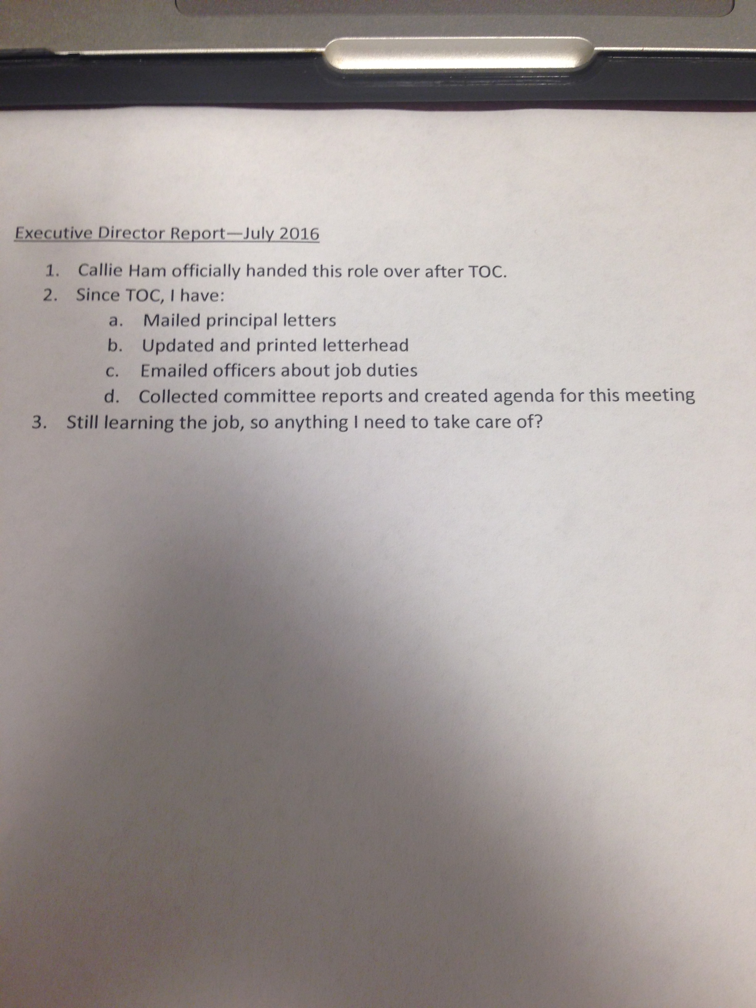

Treasurer’s Report
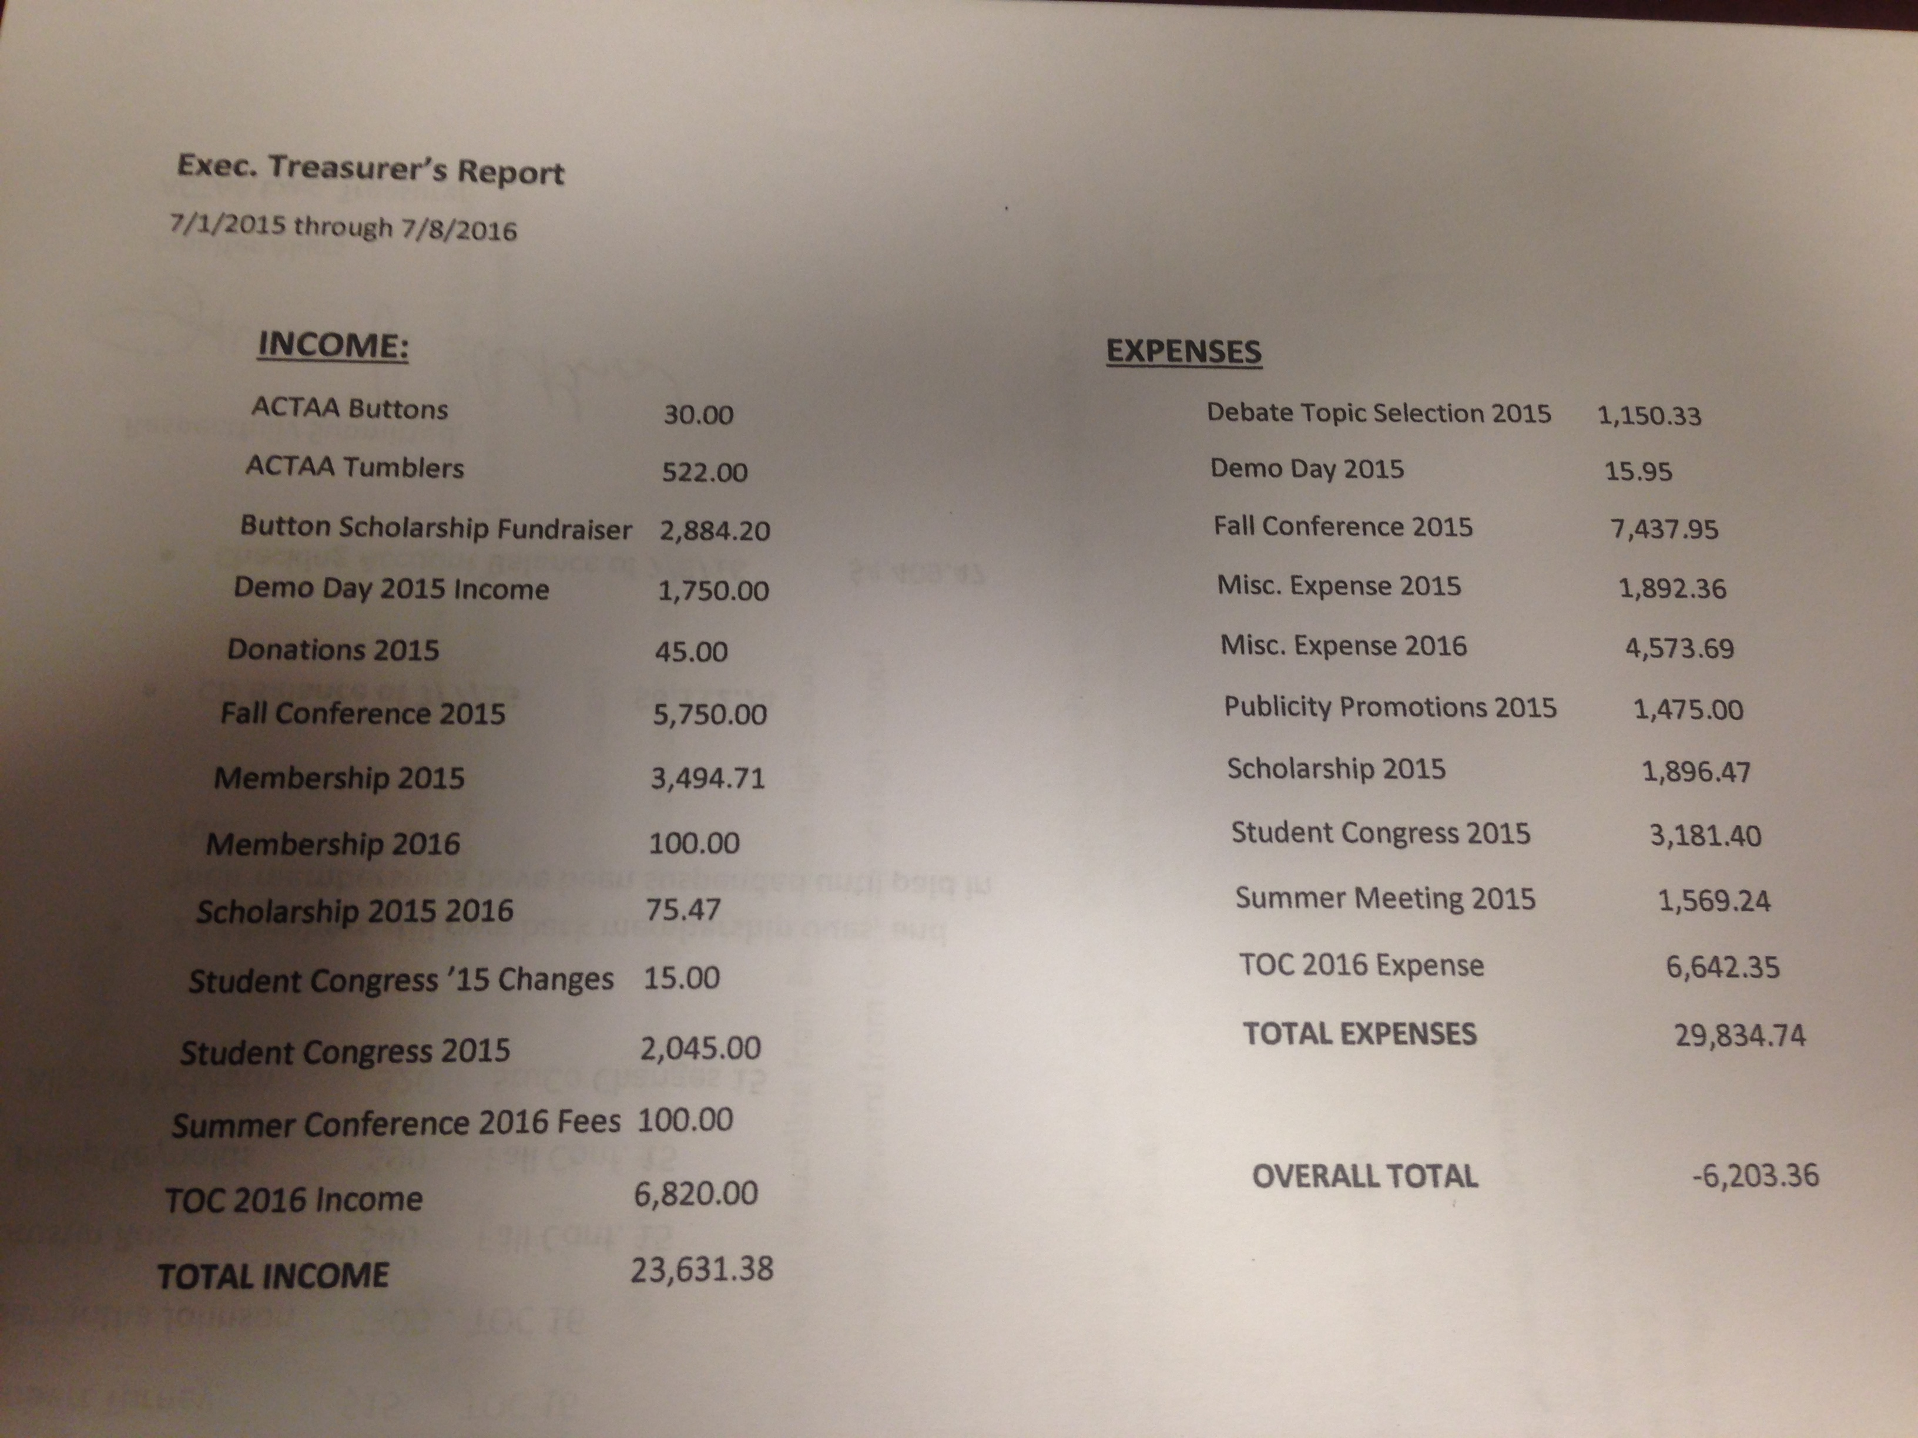

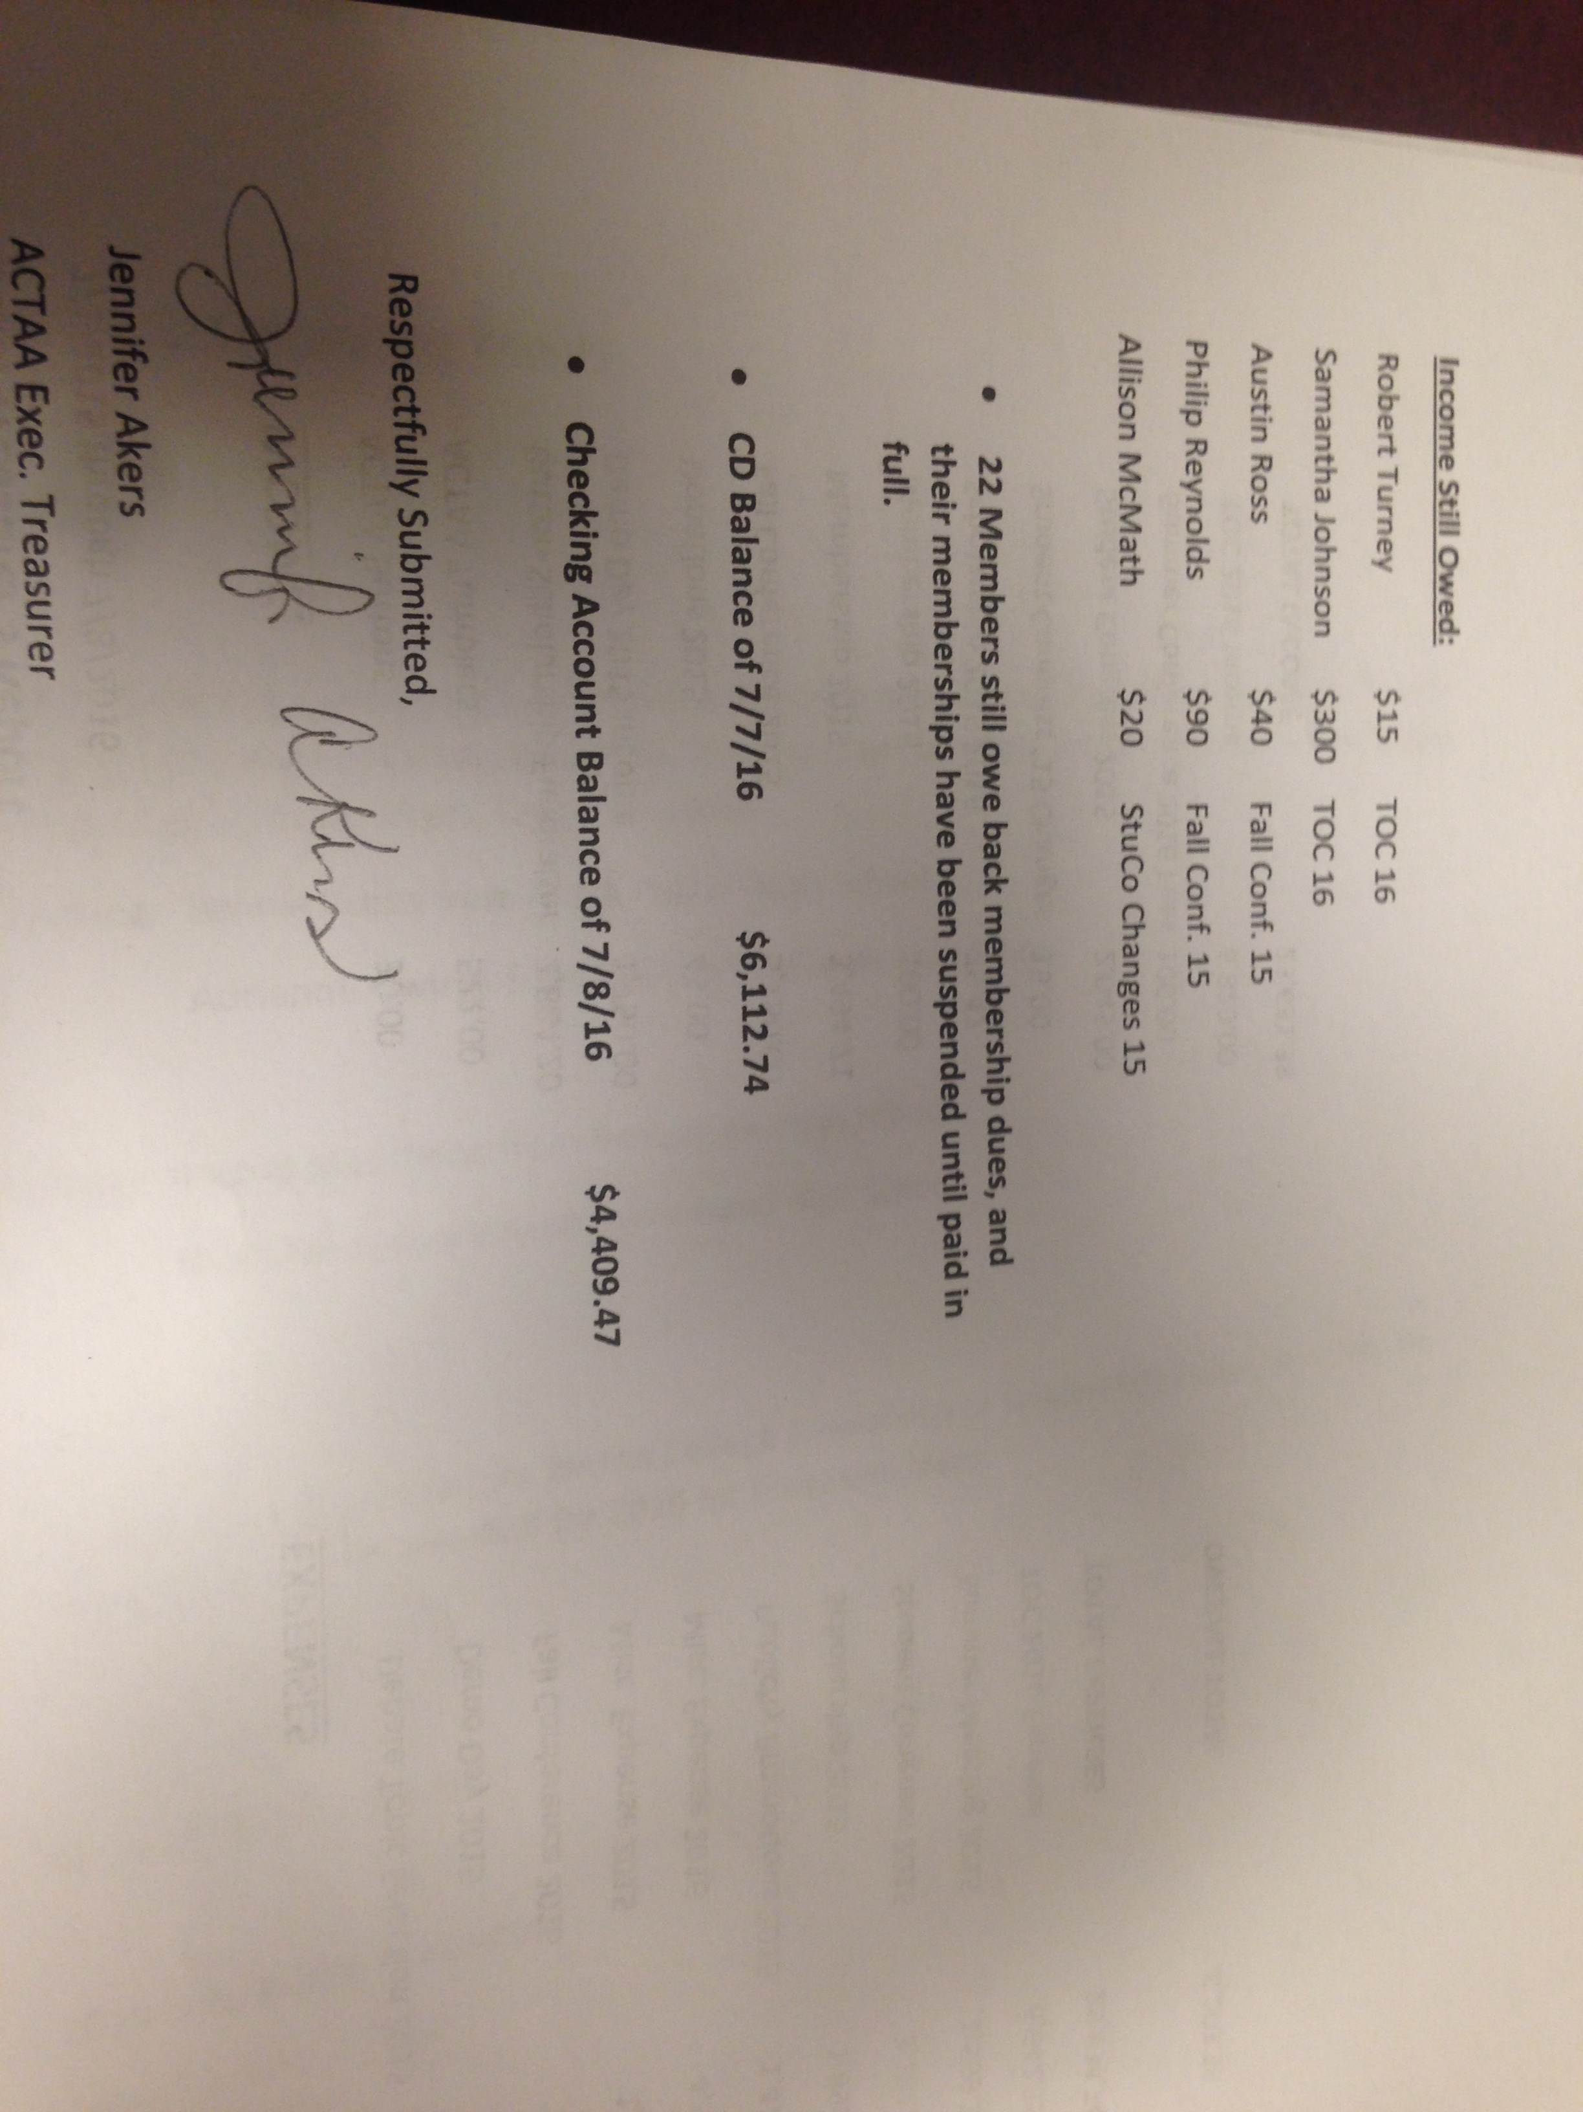

Scholarship Committee

